Experiment 9: Bidirectional Search

Aim:
To implement Bidirectional Search, a graph search technique that simultaneously explores from the start node and the goal node, reducing the search space and improving efficiency in finding the shortest path.

Algorithm:
Bidirectional Search Algorithm
- Initialize two frontiers:
  - front_start → begins from the start node
  - front_goal → begins from the goal node
- Maintain two visited sets:
  - visited_start
  - visited_goal
- Expand nodes alternately from both frontiers:
  - Remove a path from front_start
  - Expand its last node
  - Add new paths to the frontier
  - Check if any expanded node appears in visited_goal
    - If yes → meeting point found
- Repeat the same expansion for front_goal:
  - Remove a path
  - Expand
  - Add new paths
  - Check if any expanded node appears in visited_start
- When a meeting point is found:

  - Combine the forward path and the reversed backward path
  - Return the complete path
- If both frontiers become empty → no path exists.

Flowchat:



Source code:
from collections import deque

def bidirectional_search(graph, start, goal): if start == goal:
return [start]

# Frontiers for forward and backward search front_start = deque([[start]])
front_goal = deque([[goal]])

# Visited sets visited_start = {start} visited_goal = {goal}

while front_start and front_goal:

# ---- Expand from start side ----path_start = front_start.popleft() node_start = path_start[-1]

for neighbor in graph[node_start]: if neighbor not in visited_start:
visited_start.add(neighbor) new_path = path_start + [neighbor] front_start.append(new_path)

# Meeting point found
if neighbor in visited_goal:
# Find the matching path from goal side for p in front_goal:
if p[-1] == neighbor:
return new_path + p[-2::-1]

# ---- Expand from goal side ----path_goal = front_goal.popleft() node_goal = path_goal[-1]

for neighbor in graph[node_goal]: if neighbor not in visited_goal:

visited_goal.add(neighbor) new_path = path_goal + [neighbor] front_goal.append(new_path)

# Meeting point found
if neighbor in visited_start:
# Find the matching path from start side for p in front_start:
if p[-1] == neighbor:
return p + new_path[-2::-1]

return None
#
# Example bidirectional graph #
graph = {
'A': ['B', 'C'],
'B': ['A', 'D', 'E'],
'C': ['A', 'F'],
'D': ['B'],
'E': ['B', 'G'],
'F': ['C'],
'G': ['E']
}

path = bidirectional_search(graph, 'A', 'G') print("Path found:", path)

Output:

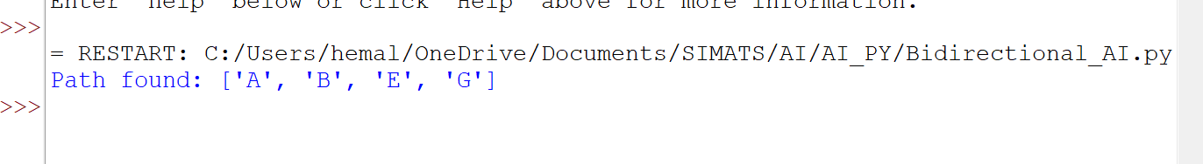

Result:
The Bidirectional Search successfully finds the shortest path between A and G by simultaneously exploring from both ends. The two searches meet at node E, producing the final path:
A → B → E → G
This confirms that Bidirectional Search reduces search time by exploring from both directions ands meeting in the middle.

